Be Courteous
Calm Patient
Reassure Patient and Family
Respect Family
Be Confident
Follow Your Training Steps
Give Directions
Keep Detailed Records
Clear Radio Communications
Move Quickly
Is This a Pack and Go?
Ongoing Assessments
Vitals, Vitals, Vitals
Monitor and Reassess
Unstable: 3-5 min.
Stable: 10-15 min.

Breath and Think

Assume Multiple Injuries

Scene Size-Up
Scene Safety
Do Not Become A Patient
General Impression
MOI or NOI
Obstacles/Extrication
Determine number of patients
Standard Precautions
Introduction/Consent
Radio Call: (I Will Advise?)
Give Location
Equipment and Patroller Needs?

Primary Assessment
(ABCDE’s) and Radio Call
Stop Bleeding (XABC in EMS)
Chief Complaint (Treat later)
Medical History
Airway
Breathing
Circulation
Disability (Head/Neurological)
Monitor LOR X 4
AVPU, Glasgow Coma Scale
Shock, Stroke, Diabetes
Examine Chief Complaint
Expose
CMS
Medical History (Previous Secondary)
SAMPLE
OPQRST
* Second Radio Call if Needed

Secondary Assessment
Physical Exam
Full Body - Head to Toe
DCAP-BTLS
Bracelets
Expose and CMS
Reassessment and Transport
Treat and Interventions
Ongoing Re-Assessments
Manage the Scene
Monitor Vitals
Collect/Annotate Info
Communicate with Patient
Proper Transport Method

Radio Calls
Location
Ambulance?
Sex, Age, Place, Vitals
Equipment (O₂)
Patrollers
Family/Contact Info
Destination and ETA

Glasgow Coma Scale
Motor
6 - Obeys commands
5 - Localizes to stimuli
4 - Withdraws for stimuli
3 - Abnormal flexion
2 - Extensor response
1 - No response

Verbal Response
5 - Alert and oriented
4 - Confused yet coherent
3 - Inappropriate words
2 - Incomprehensible sounds
1 - No sounds

Eye Opening
4 - Spontaneous eye opening
3 - Eyes open to speech
2 - Eyes open to pain
1 - No eye opening
AVPU
A - Alert
V - Verbal
P - Pain
U - Unresponsive

SAMPLE
S - Signs and Symptoms
A - Allergies
M - Medications
P - Past Medical History
L - Last Oral Intake
E - Events Leading Up To...

OPQRST
O - Onset
P - Provoking Factors
Q - Quality
R - Radiation
S - Severity
T - Time

DCAP-BTLS
D - Deformities
C - Contusions
A - Abrasions
P - Punctures
B - Burns/Bleeding
T - Tenderness
L - Lacerations
S - Swelling

PERRL
P - Pupils
E - Equal
R - Round
R - Reactive (to)
L - Light

Check - Call - Care

Be Professional
Be Appropriate
No Short Cuts
No Hiding – Act

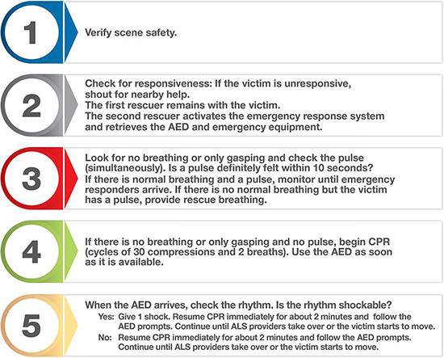
Continuing Care
Vitals: Stable 10-15, Unstable 3-5
Annotate, Keep detailed notes
Follow your training Steps
Be courteous
Reassure patient and family
Give directions – Patrollers will support
Move Efficiently
Is this a “Pack and Go?
Professionalism
Service
Respect
Courtesy
We Are There!

This Is What We Do
Assessment
Treatment
Packaging
Shipping
1. Scene Size-Up
2. Primary Assessment
3. Secondary Assessment
You will be nervous
Stop, collect yourself, breathe, think
Practice – Practice - Practice
Follow Your Training!
Radio Calls and Top Shack/Dispatch
Radio Étiquette
Equipment Needs (O₂?)
Ambulance Needs
Sex, Age, Place, Vitals
General Situation
Patrol Needs
Contact/Family/Group Information
Where are you going? ETA
Talk – Debrief with Other Patrollers and Your Hill Captain
Complete The Incident Report and Mobile/Online Forms Accurately
Support Your Team of Patrollers

